Non-Conformance 2

1. Main Menu

1.1 Non-Conformance: Part 2 of 5
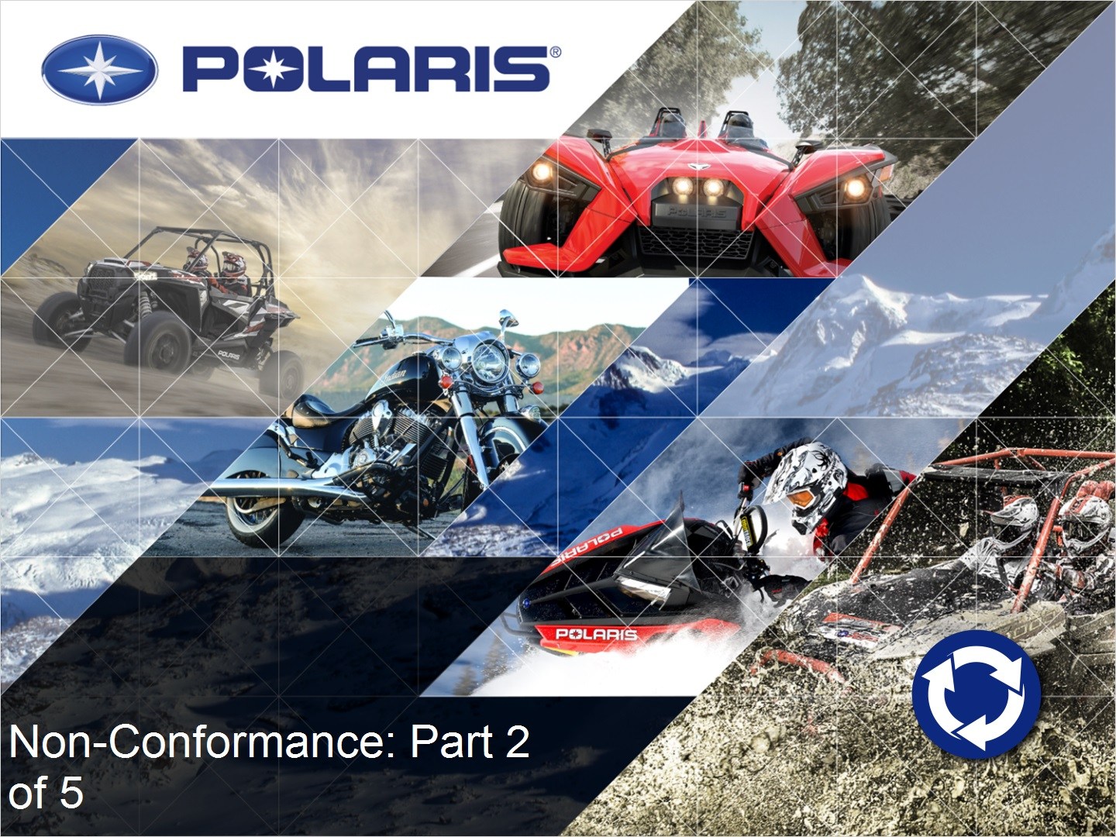

1.2 Welcome!


1.3 Define Phase Flow
